PYSPARK

Mini Project

Inventory Management

Table of Contents
1 Introduction 3
1.1 Setup Checklist for Mini Project 3
1.2 Instructions 3
2 Problem Statement 4
2.1 Objective 4
2.2 Abstract of the project 4
2.3 Technology used: 4
3 Implementation in PYSPARK LOT 5
3.1 Summary of the functionality to be built: 5
3.2 Guidelines on the functionality to be built: 5
4 Reports to be built 8
5 Appendix (source Files) 10

Introduction
This document outlines a mini project for the PYSPARK LOT. The project is to develop Analysis & Reporting System of Inventory Management.This document contains the work flow of the system and gives guidelines on how to build the functionality gradually in each of the course modules of the PYSPARK LOT.

Setup Checklist for Mini Project
Minimum System Requirements

- Hardware:
    - Intel Pentium 90 or higher (P166 recommended)
    - Microsoft Windows 2010 or above.
    - Memory: 4GB of RAM (4GB or more recommended)
- Software:
    - Anaconda
    - Python
    - IDE – Pycharm/Jupyter Notebook
    - Pyspark
    - Internet Explorer 10.0 or higher

NOTE: Anaconda will install Python. Other tools like Jupyter notebook, Spyder can be installed through Anaconda as well.

Instructions
- The code modules in the mini project should follow all the coding standards.
- Create a directory by your name in drive <drive>. In this directory, create a subdirectory MiniProject. Store your Project here.
- You can refer to your course material.
- You may also look up the help provided in the PYSPARK docs and documentation provided in respective tools.

Problem Statement

Objective
Development of a Analysis & Reporting System of Inventory Management.

Abstract of the project
The project is to develop Analysis & Reporting System of Inventory

Technology used:

- Anaconda
- Python
- IDE – Pycharm/Jupyter Notebook
- PySpark

Implementation in PYSPARK LOT

Summary of the functionality to be built:
The participants need to develop the Analysis & Reporting System of Inventory Management by building the functionality incrementally in each of the course modules of PYSPARK LOT.

Guidelines on the functionality to be built:

Project flow

Heterogeneous Sources i.e. operational data (Flat files)
EXTRACT
Load
Transform
In-memory
Dimension Model using PySpark
REPORTS

(CSV)

The participants are expected to create a star/snowflake schema model based on the OLTP source files shared with them
The source file has the following data
- Source File 1
  - Date
  - Transaction ID
  - PRODUCT Name
  - PRODUCT Brand
  - Product Model No.
  - Customer Name
  - Seller_ID
  - Product Cost Price
  - Product Selling Price

The OLAP schema diagram is as shown below

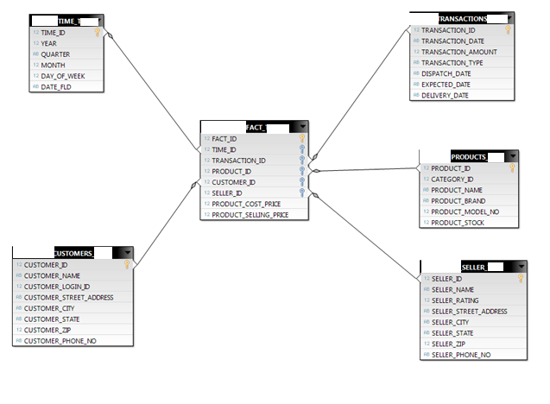

The Dimension tables are
  - Customers
    - CUSTOMER_ID
    - CUSTOMER_NAME
    - CUSTOMER_LOGIN_ID
    - CUSTOMER_STREET_ADDRESS
    - CUSTOMER_CITY
    - CUSTOMER_STATE
    - CUSTOMER_ZIP
    - CUSTOMER_PHONE_NO
  - Products
    - PRODUCT_ID
    - CATEGORY_ID
    - PRODUCT_NAME
    - PRODUCT_BRAND
    - PRODUCT_MODEL_NO
    - PRODUCT_STOCK
  - Seller
    - SELLER_ID
    - SELLER_NAME
    - SELLER_RATING
    - SELLER_STREET_ADDRESS
    - SELLER_CITY
    - SELLER_STATE
    - SELLER_ZIP
    - SELLER_PHONE_NO
  - Time
    - TIME_ID
    - YEAR
    - QUARTER
    - MONTH
    - DAY_OF_WEEK
    - DATE

  - Transaction
    - TRANSACTION_ID
    - TRANSACTION_DATE
    - TRANSACTION_AMOUNT
    - TRANSACTION_TYPE
    - DISPATCH_DATE
    - EXPECTED_DATE
    - DELIVERY_DATE
Fact Tables are
  - Inventory
    - FACT_ID
    - TIME_ID
    - TRANSACTION_ID
    - PRODUCT_ID
    - CUSTOMER_ID
    - SELLER_ID
    - PRODUCT_COST_PRICE
    - PRODUCT_SELLING_PRICE

Note: The datatype/length for the Dimension/Fact table attribues can be changed as required. Additional fields can be added, if required.

Data Transformation for data warehouse:

- Load the Data into Dimension tables using the CSV files provided.
- Load the Data into Fact tables using the CSV files provided.
- Populate Dimension tables before fact table
- Dimension table should have unique values with unique system generated IDs. Rank() function can be used to generate the unique ID (sequence). Same for Fact ID
- Other ID columns in Fact table example in Players Fact table – transaction_id, customer_id, seller_id etc. column should be populated with id columns values from corresponding dimension table

Reports to be built

Following reports to be created. Create CSV file output for each report. Reports to be generated from the Fact and Dimension tables

- Transaction Amount Wise Top 10 Customers

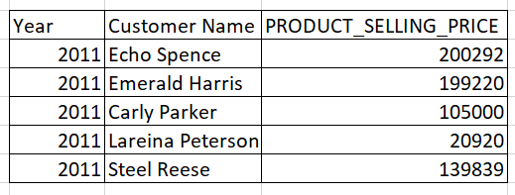

- State wise number of orders

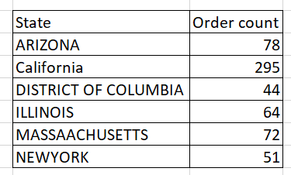

- Preferred mode of payment across states

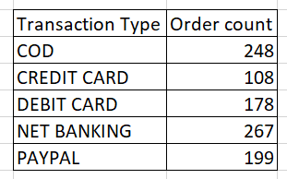

- Quarterly profit for a particular year

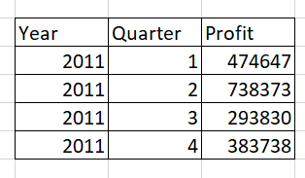

- Quarterly sales count of each product category
,
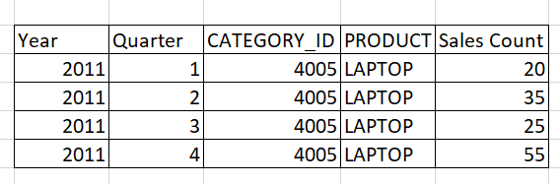

Appendix (source Files)

